

UAH Navigation

User Guide

Navigation made easier

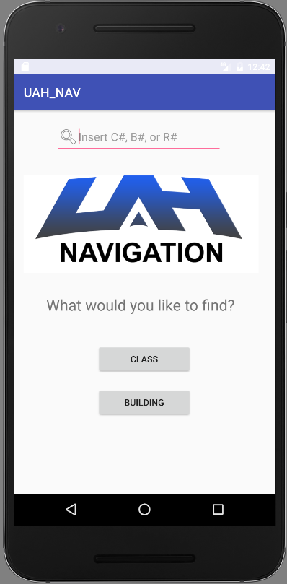

# Preface

## About This Guide

This document provides information about the services and functions available in the UAH NAV Mobile App and how to access them.

## Audience

This user guide is intended for people who want to use their mobile phone or tablet (Android 4.3 or greater) to access our navigation services.

# Contents

Preface 2

About This Guide 2

Audience 2

Contents 3

Overview 4

Starting the App 4

Using the App 4

Navigation 5

Refreshing the course listings 6

How to refresh course listings 6

Contributing to UAH NAV 7

Sending information to the developers 7

# Overview

The UAH NAV Mobile App allows the user to navigate across the UAH campus via class lookup or building lookup.

The app is designed to be easy to use, so its contains only functionality relative to navigation, building lookup, and class information.

The app is reliant on UAH’s course schedule menu. If any connectivity issues occur, check the status of your mobile data provider first then with UAH’s course schedule menu server found [here](http://www.uah.edu/cgi-bin/schedule.pl).

## Starting the App

When the application is first opened, it will have an initial setup protocol that will scrape UAH’s course catalog and create local repositories for future use. Please allow at least 30 seconds for the initial boot time, after its initial boot, the app should load normally.

## Using the App

To start the app, tap the launch icon on the home screen of your mobile device.

**Note**: This app requires your mobile device to be connected to the Internet and GPS satellites. If you have never set up the Wi-Fi or GPS connection for your device, refer to your device’s documentation for instructions.

The first time you start the application, you will be greeted by the following message.

Insert splash screen logo here.

After the one time initialization process is complete, the application will load normally.

**Note**: Initialization should take 30 seconds or less, check your devices connectivity if the process is taking longer.

## Navigation

The mobile app first opens on the Dashboard.

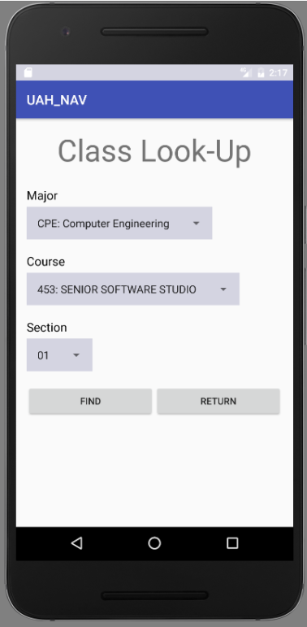 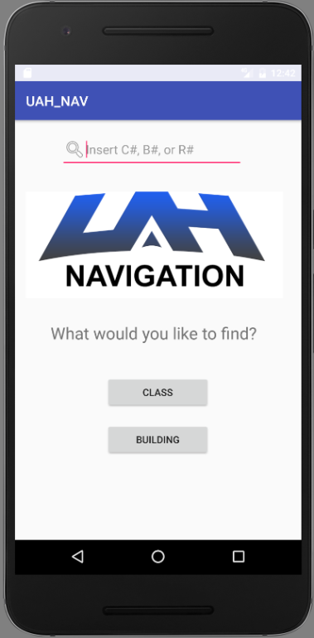 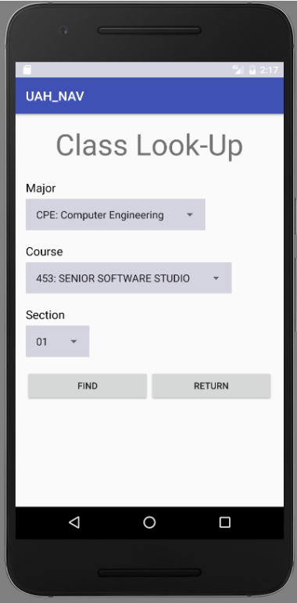

# Refreshing the course listings

As the UAH course catalog updates, your app’s local repositories may become out of date and potentially provide you with misleading information.

## How to refresh course listings

If you feel that your application needs to refresh its local files with the remote files simply navigate to SETTINGS menuby pressing on the cog wheel in the upper right hand corner of the splash screen and press the REFRESH button. Your application will automatically update every new semester; only in rare scenarios will your local files be out of date with UAH’s course listings.

# Contributing to UAH NAV

The UAH campus is constantly under renovation and construction. Naturally the information provided in UAH NAV will become out of date with the layout of the campus and it will require a manual update.

## Sending information to the developers

If you notice that any navigation routes, room locations, building locations, or landmarks are outdated due to recent renovation on the UAH campus. Feel free to navigate to the SETTINGS menu by pressing the cog wheel in the upper right hand corner of the splash screen and press the CONTRIBUTE button. A dialog box will pop up that allows you to send a quick message to the current app developers. Once your information has been received, they will be able to manually update the campus map in the application and push a new release. Thank you for contributing to UAH NAV!